**LIT ASSIGNMENT -DAY 14**

**Name : Bharat Pratap Singh**

**EMPLOYEE ID – 46255429**

CDS-Assignment 1 – Create a Simple CDS view with Date Functions in ABAP CDS Views

**Scenario** –

* Create a CDS view with 7 fields from VBAK using date functions

1. VBELN (Sales Document),
2. AUART (Sales Document Type),
3. AUDAT (Document Date),
4. VDATU (Requested delivery date)
5. Days between Document Date & Requested delivery date as Processing days
6. Delivery date + 10 days as shipping date
7. Delivery Date + 2 months as billing date

**Tables involved** – VBAK

Cd's View Code:

@AbapCatalog.sqlViewName: 'Z265_SQLDAY14Q1'

@AbapCatalog.compiler.compareFilter: true

@AbapCatalog.preserveKey: true

@AccessControl.authorizationCheck: #NOT_REQUIRED

@EndUserText.label: 'CDs view day14 q1 vbak table'

**define** **view** z197_cds_date_day14_q1 **as** **select** **from** vbak **{**

vbeln**,**

auart**,**

audat**,**

vdatu**,**

dats_days_between**(**audat**,**vdatu**)** **as** Processing_days**,**

dats_add_Days**(**vdatu**,**10**,**'FAIL'**)** **as** Shipping_date**,**

dats_add_months**(**vdatu**,**2**,**'FAIL'**)** **as** Billing_date

**}**

**output:**

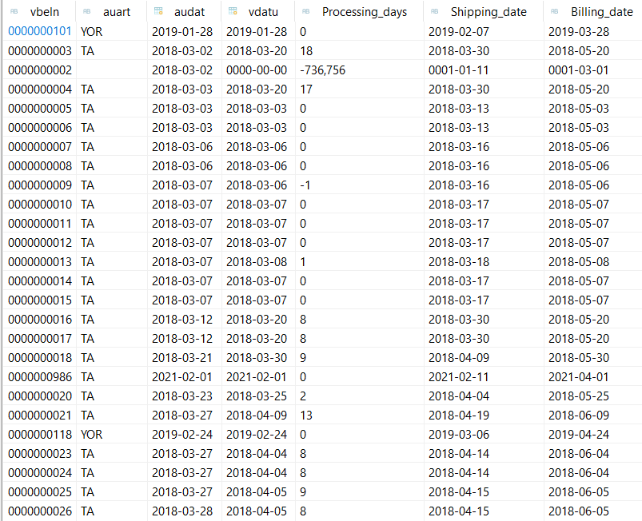    
CDS-Assignment 2 – Create a Simple CDS view with String Functions in ABAP CDS Views

**Scenario** –

* Create a CDS view with 10 fields from KNA1 using string functions

1. KUNNR (Customer Number),
2. LAND1 (Country Key),
3. Concatenate NAME1 & NAME2
4. Concatenate STRAS, ORT01 & REGIO & PSTLZ with space in between.
5. Get first 2 characters of NAME1
6. Get last 3 characters of NAME2
7. No of characters of TELF1
8. NAME1+2(4). 4 characters starting from 2nd character.
9. Remove the leading zeros of KUNNR
10. Remove last 4 characters of TELF1.

**Tables involved** – KNA1

cds view code

@AbapCatalog.sqlViewName: 'Z197SQLDATE'

@AbapCatalog.compiler.compareFilter: true

@AbapCatalog.preserveKey: true

@AccessControl.authorizationCheck: #NOT_REQUIRED

@EndUserText.label: 'cds view day14 q2 kna1 table'

**define** **view** Z197_cds_date_day14_q2 **as** **select** **from** kna1 **{**

    kunnr**,**

    land1**,**

    concat**(**name1**,**name2**)** **as** name**,**

    concat_with_space**(**concat_with_space**(**stras**,**ort01**,**1**),**concat_with_space**(**regio**,**pstlz**,**1**),**1**)** **as** address**,**

    left**(**name1**,**2**)** **as** l2_name**,**

    right**(**name2**,**3**)** **as** r3_name**,**

    length**(**telf1**)** **as** length_telf1**,**

    substring**(**name1**,**2**,**4**)** **as** sub_name**,**

    ltrim**(**kunnr**,**'0'**)** **as** remove_kunnr**,**

    replace**(**telf1**,**right**(**telf1**,**4**),**''**)** **as** replace_telf1

**}**

**output:**

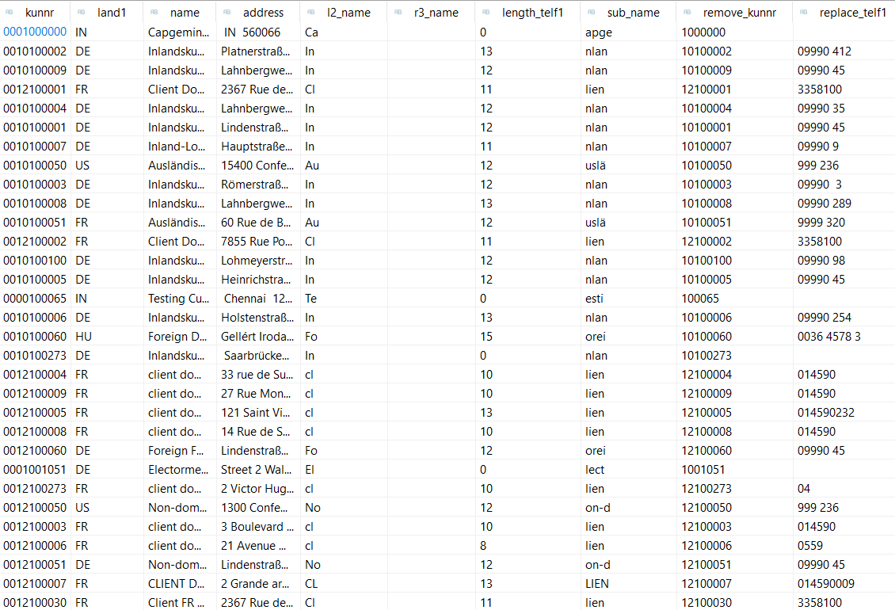

CDS-Assignment 3 – Create a Simple CDS view with Parameters

**Scenario** –

* Create a CDS view with GL currency (PSWSL) as parameter and get the entries form BSEG

**Tables involved** – BSEG

CDS view Code:

@AbapCatalog.sqlViewName: 'Z265SQLPARAV'

@AbapCatalog.compiler.compareFilter: true

@AbapCatalog.preserveKey: true

@AccessControl.authorizationCheck: #NOT_REQUIRED

@EndUserText.label: 'parameter view day14 q3'

**define** **view** z197_cds_para_day14_q3

**with** **parameters** gl_currency  **:** *pswsl*

**as** **select** **from** bseg **{**

bukrs**,**

belnr**,**

gjahr**,**

buzei**,**

pswsl

**}** **where** pswsl **=** **$parameters.**gl_currency

output:

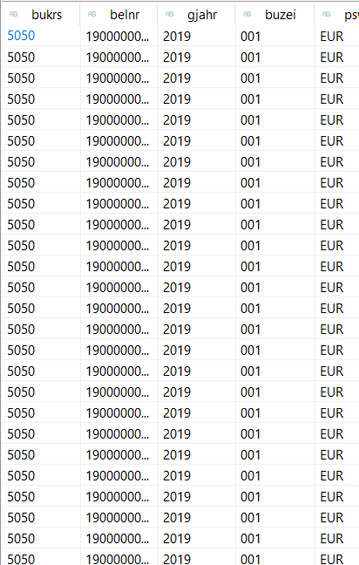

AMDP-Assignment 1 – Procedures - create a basic procedure to fetch data with scalar variable

**Scenario** –

* Print Sales Order number, Material Number, Quantity from VBAP table using scaler variable

**Tables involved** – VBAP

Amdp Class :

class Z197_AMDP_DAY14Q4 definition

  public

  final

  create public .

  public section.

  TYPES:BEGIN OF TY_vbap,

      vbeln   TYPE vbeln_va,

      matnr   TYPE matnr,

      zmeng   TYPE  dzmeng,

        END OF TY_vbap.

    TYPES: it_vbap TYPE STANDARD TABLE OF ty_vbap WITH EMPTY KEY.

   INTERFACES IF_AMDP_MARKER_HDB.

   class-METHODs get_details

    IMPORTING

      VALUE(iv_vbeln) TYPE vbeln

    EXPORTING

      VALUE(et_order) TYPE it_vbap.

  protected section.

  private section.

ENDCLASS.

CLASS Z265_AMDP_DAY14Q4 IMPLEMENTATION.

METHOD get_details BY DATABASE PROCEDURE

                  FOR HDB

                  LANGUAGE SQLSCRIPT

                  USING vbap.

et_order = SELECT vbeln,

                   matnr,

                   zmeng

                   From vbap where vbeln = iv_vbeln;

    endmethod.

ENDCLASS.

**Execution Code:**

REPORT z265_amdp_day14q4.

PARAMETERS : p_vbeln type vbeln.

z265_amdp_day14q4=>GET_DETAILS(

  exporting

    IV_VBELN = p_vbeln

  importing

    ET_ORDER = data(ta_vbap)

).

cl_demo_output=>display_data(

  EXPORTING

    value = ta_vbap

    name  = 'Sales Details'

).

**output:**

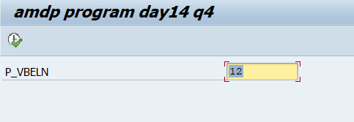

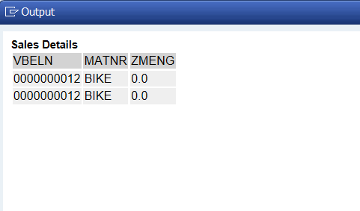

AMDP-Assignment 2 – Procedures - create a basic procedure with Table

**Scenario** –

* Select VBELN, VKORG, MATNR, MENGE from VBAK and VBAP and display the data using table based on material (MATNR).
* MATNR will be input field
* Do inner join

**Tables involved** – VBAK, VBAP.

Code:

class Z197_AMDP_DAY14Q5 definition

  public

  final

  create public .

  public section.

   TYPES:BEGIN OF TY_SALES,

        VBELN TYPE VBELN_VA,

        VKORG TYPE VKORG,

        MATNR TYPE MATNR,

        MATKL TYPE MATKL,

        END OF TY_SALES.

    TYPES IT_SALES TYPE TABLE OF TY_SALES.

    INTERFACES IF_AMDP_MARKER_HDB.

   CLASS-METHODS

        GET_SALES

            IMPORTING VALUE(IM_MATNR) TYPE MATNR

            EXPORTING VALUE(EX_SALES) TYPE IT_SALES.

  protected section.

  private section.

ENDCLASS.

CLASS Z265_AMDP_DAY14Q5 IMPLEMENTATION.

 METHOD GET_SALES BY DATABASE PROCEDURE

                     FOR HDB

                     LANGUAGE SQLSCRIPT

                     USING VBAK VBAP.

    EX_SALES = SELECT V1.VBELN,

                      V1.VKORG,

                      V2.MATNR,

                      V2.MATKL

                   FROM VBAK AS V1 INNER JOIN VBAP AS V2

                   ON V1.VBELN = V2.VBELN

                   WHERE MATNR = IM_MATNR;

endmethod.

ENDCLASS.

**Program Code:**

REPORT z265_amdp_day14q5.

Parameters : p_matnr type matnr.

z265_amdp_day14q5=>GET_SALES(

  exporting

    IM_MATNR = p_matnr

  importing

    EX_SALES = DATA(RS_VBAK)

).

CL_DEMO_OUTPUT=>display_data(

  EXPORTING

    value = RS_VBAK

    name  = 'Sales Order Details using Join'

).

**output:**

